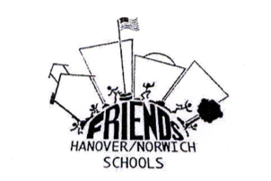
FRIENDS OF THE HANOVER AND NORWICH SCHOOLS:
PROJECT APPLICATION
Please scan a completed, signed application and email to
fhns1961@gmail.com

Name of Project:____________________________________________

Submitted by:________________________________________________
(include email)

Subject Area/Grade/School:________________________________________________

Number of Students Involved:________________

Brief Project Description:____________________________________________________________________________
_________________________________________________________________________________________________________
_________________________________________________________________________________________________________
_________________________________________________________________________________________________________

Brief Budget Overview:____________________________________________________________________________

Total Amount Requested:____________________________

Comments by Principal:(How does this proposal support school goals, etc.?)__________________
_________________________________________________________________________________________________________
_________________________________________________________________________________________________________
_________________________________________________________________________________________________________

Endorsement of Principal:__________________________________________________________________________

Date Submitted:_____________________________________

Please provide any other relevant information you feel necessary to support your presentation.

You will be notified by committee of date/time of presentations.

All communication should be through principal or through email to fhns1961@gmail.com

