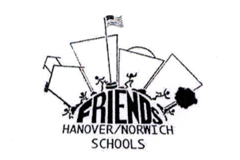
FRIENDS OF THE HANOVER AND NORWICH SCHOOLS: PROJECT EVALUATION
This evaluation is due upon completion of the project
Please scan and email to: fhns1961@gmail.com
Or mail to
Friends of Hanover and Norwich Schools
P.O. Box 882, Hanover, NH 03755

Name of Project:_____________________________________________

Submitted by:________________________________________________ Date:______________________
(include email)

Brief Project Description:____________________________________________________________________________
_________________________________________________________________________________________________________
_________________________________________________________________________________________________________
_________________________________________________________________________________________________________

Total Expenditure:______________________________

Date Completed:_____________________________

Evaluation of project and how measured:______________________________________________
_________________________________________________________________________________________________________
_________________________________________________________________________________________________________

Will this project need future funding from school budget?____________________ if yes, please provide some details_________________________________________________________________________________
_________________________________________________________________________________________________________

Other Comments: __________________________________________________________________________________________________________________________________________________________________________________________________________________

Was this grant publicly acknowledged? ___________
How: newsletter, performance/program/playbill, assembly, letter to editor, other
_________________________________________________________________________________________________________

All communication should be through principal or through email to fhns1961@gmail.com

